**While Loop:** continually runs during the operation of the robot, determining the potentially changing the speed of the spinner motor

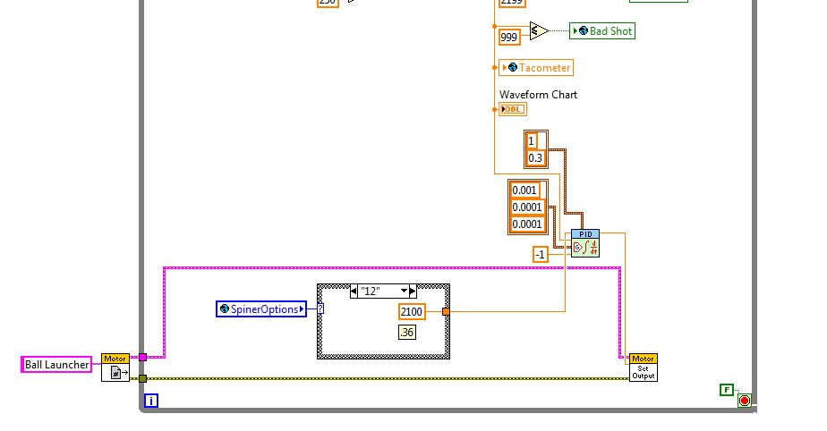

**Encoder Rate Calculation**: takes the original encoder rate, applies an ENCODER-SPECIFIC calculation for the encoder to get the rotation per minute of the spinner wheel.

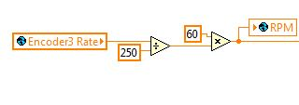

**Case structure:** depends on the input of “SpinnerOptions” (which are chosen by the user and represented primarily as feet from the target), and sends a corresponding RPM value to the PID.

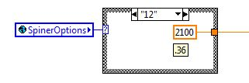

**Motor Movement:** A reference to the motor is opened up outside of the while loop and then connected to motor set output vi (which gets its input from the PID). This allows the movement of the motor.



**Range Checks**: takes the RPM of the encoder, determines what range it is in, and sends a true to the corresponding Boolean global variable and false to all the other ones.

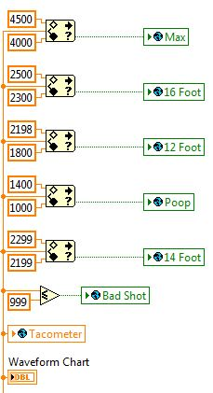

**PID**: Takes current RPM of the encoder and the desired RPM and then outputs a corresponding value to the motor (between 0.3 and 1). Note: other options on the PID were determined by primarily trial and error.

C:\Users\Feds201-1\Google Drive\Programming\Feds201 Manual\Images\SetVelocity.VI\VI View.JPG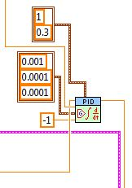

**Note:** This VI is nested inside of the **Periodic Tasks.VI,** the icon looks like this: